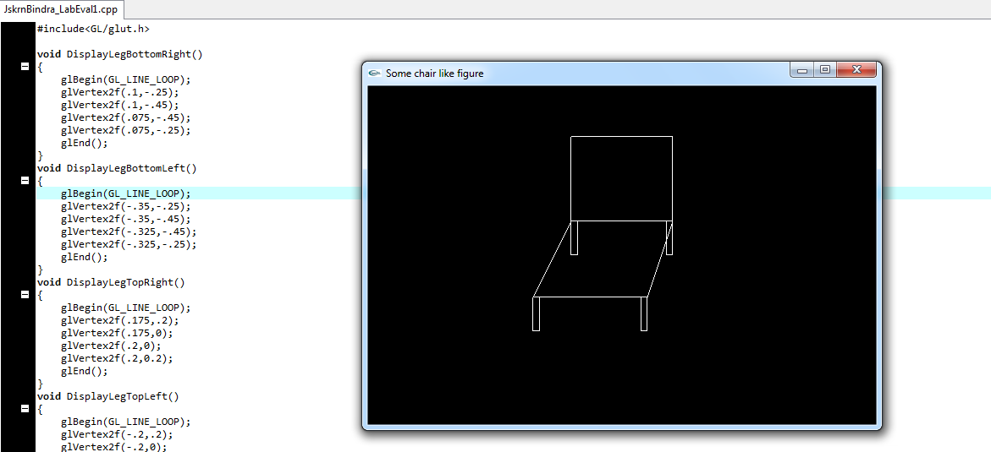

#include<GL/glut.h>

void DisplayLegBottomRight()
{
glBegin(GL_LINE_LOOP);
glVertex2f(.1,-.25);
glVertex2f(.1,-.45);
glVertex2f(.075,-.45);
glVertex2f(.075,-.25);
glEnd();
}
void DisplayLegBottomLeft()
{
glBegin(GL_LINE_LOOP);
glVertex2f(-.35,-.25);
glVertex2f(-.35,-.45);
glVertex2f(-.325,-.45);
glVertex2f(-.325,-.25);
glEnd();
}
void DisplayLegTopRight()
{
glBegin(GL_LINE_LOOP);
glVertex2f(.175,.2);
glVertex2f(.175,0);
glVertex2f(.2,0);
glVertex2f(.2,0.2);
glEnd();
}
void DisplayLegTopLeft()
{
glBegin(GL_LINE_LOOP);
glVertex2f(-.2,.2);
glVertex2f(-.2,0);
glVertex2f(-.175,0);
glVertex2f(-.175,.2);
glEnd();
}
void DisplayQuad2()
{
glBegin(GL_LINE_LOOP);
glVertex2f(-.2,.2);
glVertex2f(-.35,-.25);
glVertex2f(.1,-.25);
glVertex2f(.2,.2);
glEnd();
}

void DisplayShape()
{
//Displaying Quad 1
glClear(GL_COLOR_BUFFER_BIT);
glBegin(GL_LINE_LOOP);
glVertex2f(-.2,.2);
glVertex2f(.2,.2);
glVertex2f(.2,.7);
glVertex2f(-.2,.7);
glEnd();
//Quad 1 code ends

//Displaying others
DisplayQuad2();
DisplayLegTopLeft();
DisplayLegTopRight();
DisplayLegBottomLeft();
DisplayLegBottomRight();
glFlush();

}

int main(int argc,char **argv)
{
glutInit(&argc,argv);
glutInitDisplayMode(GLUT_RGB|GLUT_SINGLE);
glutInitWindowSize(600,400);
glutInitWindowPosition(400,200);
glutCreateWindow("Some chair like figure");
glutDisplayFunc(DisplayShape);
glutMainLoop();}

